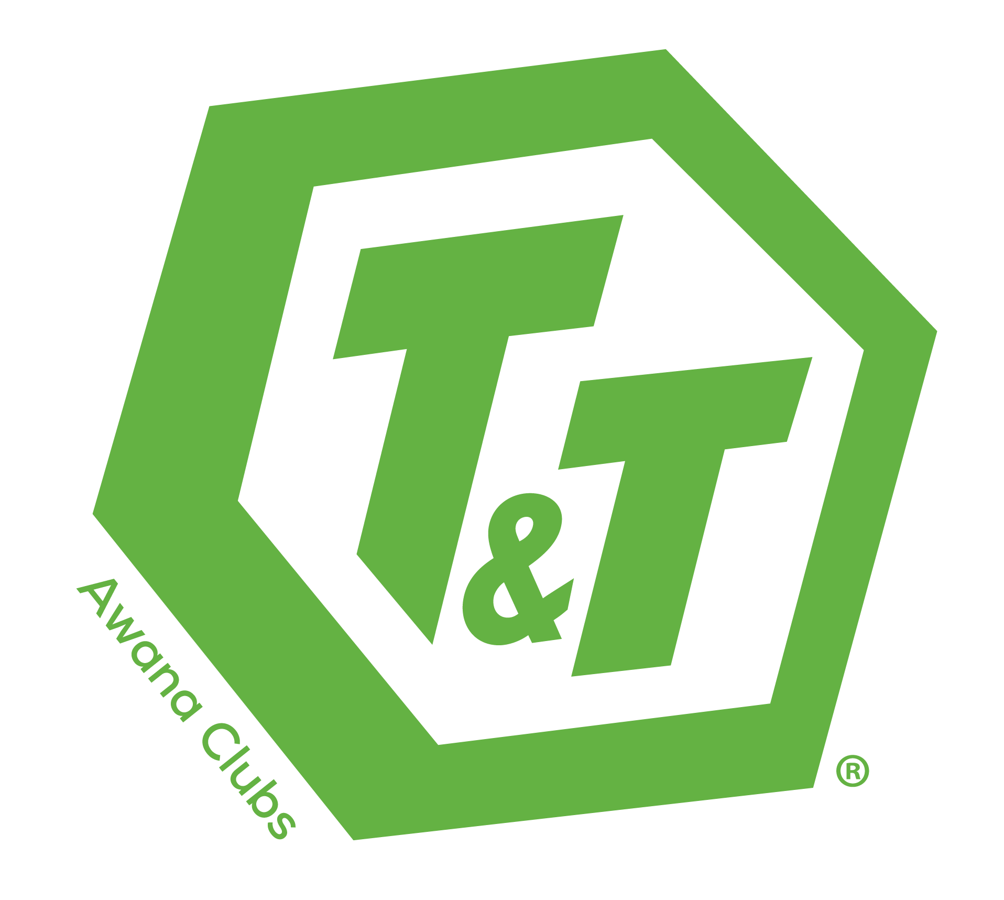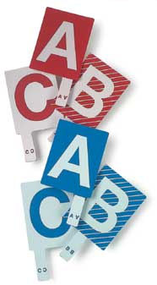
Truth and Training
Bible Quiz Rulebook 2019
Fredericktowne Baptist Church and
Rosedale Baptist Church

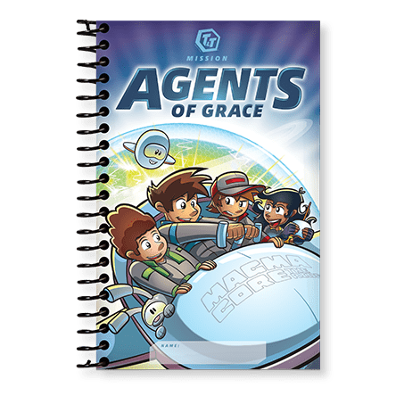
Introductory Note
Bible Quizzing is the Scripture memory counterpart to the physical, game-oriented AwanaGames™. Both use the element of competition as a motivating factor. This event motivates students to increase their Bible knowledge while giving participants, leaders and even parents an intense exposure to Scripture. Bible Quizzing tests students’ knowledge of material in handbooks and provides individual recognition and awards.

Bible Quizzing stimulates Scripture memorization and motivates students to stay up-to-date in their handbooks. Young people memorize more verses, complete more handbooks and comprehend more Bible truths with the incentive of making their church’s Bible Quiz team and competing for honors at the local and regional level. As students spend more time preparing for Bible Quizzing, their parents also become exposed to the truths of God’s Word. Bible Quizzing promotes fellowship between Awana programs in the same church as well as other Awana-registered churches.

Quizzing Objectives
Awana wants all children and youth to come to know, love, and serve the Lord Jesus Christ. This is discipleship in its purest form. Bible Quiz assists in building disciples through these objectives:
- To proclaim God’s wonderful grace and salvation through Bible quiz questions. Parents and friends may then see their need of becoming a Christian and be challenged to accept Christ as Savior.
- To promote and encourage young people in Bible memorization and review of their Awana handbooks/manuals.
- To provide a competitive atmosphere in which participants can display their Bible knowledge and gain a sense of accomplishment.
- To give young people a greater love for – and working knowledge of – the Bible.
- To build quiz–leader–participant relationships.

Quiz Format Overview
Awana Bible Quizzing incorporates three segments. These segments are:

- Individual multiple-choice (12 questions)
- Individual speed (12 questions)
- Individual written (12 questions)

Scores from each segment are combined to determine individual and team awards.

Multiple-choice Quizzing
The multiple-choice segment (commonly known as paddle quizzing) allows participants to perform in a low-key competitive atmosphere. Participants from each book are given an opportunity to answer a series of multiple-choice questions.

Speed Quizzing
In the speed quizzing segment, clubbers from each book compete against other teams in the same book. There is a series of questions per book. The Quizmaster will read the question for all teams to hear. The first person to respond by buzzing in is allowed to answer the question. If that person’s answer is incorrect, then the second person to buzz in must attempt to answer the question. The Quizmaster will re-read the question before the second person attempts to give the correct answer.

Written Quizzing
The written quiz segment is when participants answer a series of questions. It is held in a room separate from the rest of the quiz meet. The team coach may accompany team members to the written quiz room. Prior to start of the written quiz, coaches will be dismissed.
One or more of the following styles may be used in the written quiz:
- Matching
- Multiple-choice
- True/False
- Fill in the blank

Written Quizmaster will score these quizzes.

Organization
- The organization of the Bible Quiz meet depends on the number of teams participating.
- A team consists of as few as a single clubber to a maximum of three clubbers.
- Each team must have a coach. A wise coach is familiar with the handbook material and the rules of Bible Quiz.
- All clubbers must have a completed and signed parental consent form.
- A team refers to the participants in each book, not to the total group of clubbers representing a church.

Registration
- Teams must register by the Saturday two weeks prior to the event. After that date, permission to register and participate in the event may be granted by the event coordinator if additional teams can be accommodated.
- Early registration could guarantee participation in situations when many teams register.
- A church may enter one or more teams per book.
- The registration fee is set to help defray quiz expenses.
- Fill out and include the following forms with your registration: Quiz Team Roster, Parental Consent Form, and Day Event Volunteer Form.

General Information
Team
- Each clubber must currently be working in the Agents of Grace handbook. Clubbers may quiz in each handbook only once. A clubber may not attend Bible Quiz at another location to quiz in the same handbook. There will be two sessions: one for 3rd and 4th graders and a second session for 5th and 6th graders. If you have only one team and they are made up of clubbers that would normally be grouped separately in those two sessions, they can quiz together in the 5th/6th grade session or they can compete as a team of one in their respective session.
- Cheering and applauding are encouraged after each answer is judged. Informality helps relax quiz participants and motivates them as they compete.

Apparel
- Awana emphasizes the importance of modesty, neatness, and cleanliness in the apparel worn by both coaches and clubbers of all ages.
- All participants (including leaders and coaches) must wear an official Awana or team uniform in order to compete.
- Awards worn on each participant’s uniform must be consistent with the book in which they are quizzing.

Substitutes
- Substitutes must be registered and listed on the team form before quizzing commences.
- Substitutes must be in the same book as the clubber for whom they are substituted.
- Substitutions may be made at the halfway point in the speed round.
- Substitutions are permitted when a clubber quizzes out during the speed round (three right answers or two wrong answers).
- Clubbers who have quizzed out may not return as a substitute.

Recording the Quiz
- No recording of questions is allowed. This means no writing, no audio recording, no video recording, no capturing of the questions by any means is allowed.
- Recording is only allowed during the practice questions. The Quizmaster should announce after the practice questions that recording must come to an end. Whether the Quizmaster makes this announcement or not, all recording must end after the practice questions.

Material Covered
All questions will be taken from the material in the latest edition of the Awana handbooks, manuals, and materials. Participants are not expected to interpret the materials.

Agents of Grace
- Start Zone
- Unit 1 and Unit 2
  - Start Here
  - Explore
    - Questions
    - Definitions
    - General Content
  - Memorize
Use of Handbooks, Bibles, etc.
Once the Opening Ceremony of the Bible Quiz event has begun, no further studying of handbooks, Bibles, or other materials is allowed.

Time-outs
The Quizmaster is the only official who can declare a time-out.

Coaches
- Each team is allowed only one official coach during the quiz meet.
- The team coach may talk to their team while the team rotates from one quiz segment to another, and as allowed by the Quizmaster during a segment.
Appeals
- Only the official coach may appeal a question or an answer.
- Only the immediate preceding question may be appealed by a coach.
- The coach makes a challenge or requests an appeal by calling out the word “challenge” before the Quizmaster says “question” to move to the next question.
- All appeals are directed to the Quizmaster. When recognized, the coach confers privately with the Quizmaster.
- After the coach voices the question, the coach must return to his or her seat while a decision is being made.
- The Quizmaster may consult with quiz judges before making a decision.
- In all cases, the decision of the Quizmaster is final.

Schedule
- Teams are to be checked in by their coach by 9:30am. The event will begin at 10:00am.
- Coaches should submit the names of their clubbers no later than the Saturday before the event. This will allow for score sheets to be prepared in advance. This will also enable any last-minute changes that arise to be accommodated quickly.
- Registered clubbers who do not show up must be reported at Bible Quiz check in.

Rules on the Three T&T Bible Quiz Segments
Individual Multiple-Choice Quizzing
- All team members from each team, by book, will be asked a series of multiple-choice questions.
- The Quizmaster prefaces each question with the word “question.” No talking is allowed from the word “question” until the answer is judged.
- Questions and possible answers will be read once. A question may be reread if the Quizmaster deems it necessary.
- Should the Quizmaster read a question improperly, the question may be discarded and a new one selected at the discretion of the Quizmaster.
- During the reading of the questions, quizzers must look down at their paddles while deciding their answers.
- There will be three answers to choose from (A, B, C). Quizzers will have five seconds to determine their choice of answers.
- When all answers have been given, the Quizmaster will say, “Think about your answer”. When the five seconds are up, the Quizmaster will call, “Paddles up.” At the call “Paddles up,” all clubbers will rapidly select and raise their answers simultaneously.
- After the “Paddles up” call has been made, no paddle may be exchanged for another paddle.
- If, in the opinion of the Quizmaster, a participant’s paddle is raised late, the participant will be disqualified from that question.
- At the “Paddles down” command, participants must lower their paddles.
- Participants are awarded 20 points for each correct answer. Incorrect answers receive zero points – no penalty.
- If a clubber answers all 12 multiple choice questions correctly, he / she earns 240 points plus 10 bonus points. This clubber also earns an individual High Honor award.
- Points count toward individual score for Bible Quiz Champion and toward the team score.
- If a judge reports inappropriate behavior from player(s) to the Quizmaster, the Quizmaster will issue a warning to the group, and the rules will be re-stated. The offending team is not identified. If the behavior is observed again for the same player(s) / team, then the team’s coach will be informed and asked to speak to their team. The Quizmaster will again re-state the rules. If the behavior is reported again after the coach has spoken to the team, the coach will again be informed; the coach will again speak to the team. The player(s) involved will receive zero points for that question, and the Quizmaster will re-state the rules. If the behavior is reported again for the same player(s), the coach will be informed, and those involved will receive zero points for any remaining questions. Those player(s) will continue to participate, but they will receive zero points for all subsequent questions – regardless of their correctness.

Note: It is understandable that new T&T clubbers, that have never attended a Bible Quiz, may not sit, without wiggling; not be able to always remember to keep their eyes on THEIR paddles; or even not always keep their hands along the sides of their paddles, and may try to select the correct paddle early, but these areas are some of the most seen issues that cause delays during Multiple-Choice Quizzing.

Individual Speed Quizzing
- Each speed quiz team consists of, at most, two participants from a team at a time.
- The third member of a team may be used as a substitute.
- The Quizmaster prefaces each question with the word “question.” No talking is allowed from the word “question” until the answer is judged.
- Help from the audience counts as a wrong answer, even if the answer is correct
- Individual speed questions will not be repeated unless the Quizmaster deems it necessary.
- Should the Quizmaster read a question improperly, the question may be discarded and a new one selected at the discretion of the Quizmaster
- Help from the audience may result in the question being disqualified, even if the answer is correct.
- All Bible verses must be quoted word-perfect according to the latest edition of the Awana handbook. If requested, the quotation must include the complete reference.
- Questions asked (other than Scripture quotations) may be answered in the participant’s own words, but must embody the truth to what the handbook states. The judges determine whether anything important to the meaning has been left out or altered
- Answers that contain extraneous information are considered incorrect, even if the correct answer is included. Coach your team to listen to the question and answer what is asked
Note: When the Quiz Master states “Listen Very Closely,” the question about to be asked, especially books of the Bible questions, has in times past been an extraneously answered question. For example, all the judges’ hearts drop when the question was, “Name the New Testament books, starting with Romans (Buzz), through and including Ephesians.” The first clubber that buzzed in answers, “Romans, 1&2 Corinthians, Galatians, Ephesians, Philippians, Colossians, 1&2 Thessalonians, 1&2 Timothy, Titus, Philemon, Hebrews, James, 1&2 Peter, 1, 2&3 John, Jude, Revelation.” The judges will be excited that the clubber called out most of the New Testament books correctly, but the answer is not what was asked for and will be deemed incorrect.
- When a speed question has been answered, the Quizmaster will ask, “Is that your answer?” Only when the quizzer answers “yes,” or time runs out (30 seconds), will the question be ruled correct or incorrect by the Quizmaster saying either “That is a correct answer,” or, “I’m sorry, that is an incorrect answer.”
- If a quiz participant quickly corrects himself or herself in the process of giving their answer, the corrected answer will be accepted
- Any clubber answering three questions correctly “quizzes out” and is awarded an extra 20 points – earning an individual High Honor award. Substitution for that team member is allowed in such a situation. (See the paragraph on Substitutes under General Information)
- Competitors having two wrong answers in the speed quiz are ineligible to answer additional questions. Another clubber, however, may be substituted. (See the paragraph on Substitutes under General Information)
- Each group of teams in a book is asked a series of questions. Correct answers from the first clubber to buzz in are awarded 20 points.
- If a clubber buzzes in before the reading of the question is completed, the Quizmaster will stop reading the question. The clubber must then attempt to answer the question based on what was read.
- An incorrect answer from the first clubber results in the loss of 10 points. If the first clubber responding is incorrect, the second clubber buzzing in will be given the opportunity to attempt the question for 10 points. The Quizmaster will automatically read the question in its entirety, and then the second clubber attempts his / her answer. An incorrect answer from the second clubber results in a loss of 5 points.
- If no clubber responds to the question in 10 seconds, or if there is no second clubber buzzed in after the first clubber answered incorrectly, time is called, and the next question given.
- From the time the microphone is available to the clubber, the clubber has 5 seconds to begin and 30 seconds to complete their answer. Grace may be extended for longer answers. However, the clubber should indicate within 5 seconds if he / she cannot answer, thereby avoiding unnecessary delays and embarrassment. Saying “um”, “my answer is”, or anything not related to the answer does not count as beginning the answer.
- Points count toward the individual score for Bible Quiz Champion and toward the team score.
- Students should be coached to speak clearly to be understood, to speak loud enough to be heard by the judges and to speak slowly enough to be followed – otherwise, the judges will consider the answer as incorrect.

Individual Written Quizzing
- The Written Quiz is the segment of Bible Quiz where all team members receive a mixture of True/False, Multiple Choice, and Matching questions.
- All team members will take an individual written quiz.
- Pencils will be provided.
- Once the participant has the Written Quiz, there should be no talking, and handbooks along with any other study material should be in the coach’s possession.
- Any questions should be addressed to the Written Quizmaster or room monitor.
- Participants must not look at another person’s paper during the quiz, or they will be disqualified.
- When completed, participants will give their test to the Written Quizmaster.
- Each correct answer earns 20 points, no penalty for incorrect answers. Questions skipped will be considered incorrect.
- If a clubber answers all 12 questions correctly, they earn 240 points plus 10 bonus points. Clubber also earns individual High Honor award.
- Points count toward the individual score for Bible Quiz Champion and toward the team score.

Scoring
- Points from all segments are totaled to form an individual’s total score.
- No penalty for incorrect answers in the Written and Multiple-Choice Quiz segments. Penalties are imposed for incorrect answers during the Speed Quiz segment.
- Team scores are determined by combining the individual scores. For teams of 1-2 players, all individual scores are added together. For teams with 3 players, the highest two scores in each segment are added together to form the team score. Alternatively, the Event Coordinator of the local church may opt to use the two highest individual total scores.

Chain of Command

- Event Coordinator- Host Church
- Quizmaster
- Judges
- Room Monitor / Timers
- Scorekeepers
- Team Coaches

Quizzing Staff
- Each church must provide at least one worker who is acquainted with Bible Quiz rules. This individual may be assigned duties, as needed, by the host church.
- Staffing, in complete uniform, is at the discretion of the Site Coordinator of the host church.
- Each staff member must arrive 30 minutes prior to the start of team check-in for staff orientation meeting.

Site Coordinator- Host Church and Team
- Makes sure facility, awards, and equipment are ready for the quiz.
- Provides copies of all quizzable material in all versions and copies of all quiz materials (Written Quiz questions, pencils, Multiple Choice Quiz questions, paddles, Speed Quiz questions, score sheets, etc.).
- Lines up and confirms staff members, ensuring Volunteer forms, if needed, are completed.
- Lines up teams for the quiz meet and sends acceptance to the teams with information on the Bible Quiz time, place, and other information.
- Keeps record of the teams registered and checks in each team at the quiz meet.

Quizmaster
- Conducts the quiz program for quizzing group.
- Maintains full authority over the quizzing group.
- Reads the quiz questions.
- Consults, if needed, the judges in any decision concerning any challenged question or answer.

Judges
- Check to make sure the Quizmaster reads the questions correctly and clearly.
- Help determine whether a quizzer’s answer is correct or incorrect in the Speed Quizzing.
- Assist the Quizmaster in any decision concerning any challenged question or answer.
- The Quizmaster makes the final decision concerning any question or answer that is challenged or appealed.

Timer
- Track the length of time to begin an answer and the length of time to complete an answer.
- Discretely signals the Quizmaster when times expire.
Head Scorekeeper / Scorekeepers
- Head scorekeeper (at staffing table) records all the individual and team points for those teams assigned to them throughout the quiz.
- Head scorekeeper oversees work assigned to assistants.
- Assistants (at staffing table) check mathematics on recorded score sheets (as assigned), and verify their work with another assistant or Head scorekeeper (as directed).
- Scorekeepers (in quiz room) record scores, verify scores with each other, and transport results to the head scorekeeper.

Summary of Points
Quiz Segment | Correct Answer | Incorrect Answer | Bonus
Individual Written | 20 | 0 | 10
Individual Multiple Choice | 20 | 0 | 10
Speed | - | - | 20
1st Person Buzzing in | 20 | -10 | -
2nd Person Buzzing in | 10 | -5 | -

Awards
- All clubbers and coaches will receive participation awards as annotated on the Participation Awards form by the coach.
- Bible Quiz Team Awards will be given to the team members and their coach for the four teams who earn the most points in each handbook grouping (1st – 4th place).
- Individual High Honor Awards will be given to any participant who scores a perfect score in the Written Quiz, scores a perfect score in the Multiple Choice (Paddle) Quiz, and/or quizzes out with three correct answers in the Speed Quizzing segment.
- Bible Quiz Champion will be awarded to the individual earning 500 or more points.
- The Streamwood Award will be given to the individual who earns the most points in each handbook.

Preparing Teams for Bible Quizzing
- Pray for your clubbers. Pray that the truths they are studying will have an impact on their lives!
- Select coaches to work with all prospective Bible Quiz competitors.
- Thoroughly review the materials and design practice questions.
- Select team members as soon as possible.
- Explain the quiz rules to team members so they know what to expect.
- Work with team members to be sure they really understand the material they have memorized.
- Instruct team members to know all verses and references (word-perfect), books of the Bible, Bible reading questions, and definitions.
- Instruct team members to listen carefully to each question, and to answer precisely.
- Consider challenging another church to a quiz for extra practice.
- Drill team members in the various types of quizzing.
- Make sure you adhere to the quizzing rules given in this book.
- If provided, attend coaches training.

Tie Breaker
The tie breaker procedure applies to two or more teams tied for any of places one through four. The procedure is used because awards are bought ahead of time for one team of players in each place, first through fourth. Breaking ties ensures there is only one team for each of these places. No points are awarded, so, at the end of the day, tied teams have the same number of points – but one team edged out the other for awards.

New tie breaker information: (different from previous years): A tie will be broken by looking at the individual quizzer’s scores on each team. The team with a higher individual score will win the tie breaker. In the event the highest individual score is a tie, then the following procedure will be used:

(Same procedure as noted in previous rulebooks)
In the event of a tie, the tied teams are asked three speed questions. All the players for both teams are eligible to participate in the tie breaker. A maximum of two (2) players per team may participate in the tie breaker round. The following procedure is used to ensure both teams have equal opportunity to win:

- Only the first clubber to buzz in answers the question.
- If no one buzzes in after 20 seconds, the quizmaster will move on to the next question.
- Once a clubber has buzzed in, the Quizmaster stops reading the question.
- There is no re-read of the question after someone buzzes in.
- After note is taken of who buzzed in first, reset the quiz machine.
- The clubber who buzzed in first gets the question right or wrong – no points are awarded.
- After three questions, if one team has more correct answers than another, they win the tie-breaker.
- If after three questions both teams have the same number of correct answers, the tie-breaker session will enter a “sudden victory” stage.
- For the fourth question, the first player to buzz in determines who wins. If the player gets the answer right, that player’s team wins; if that player gets the answer wrong, that player’s team loses. The only way to a fifth question is if no one buzzes in.
- Past the third question, play continues as “sudden victory”.

Having three questions ensures both teams get opportunity to win. It does not allow the first team to buzz in on the first question to win. Not giving a second player to buzz in a chance to answer does two things. First, it ensures two players from the same team do not get a chance at the question. Second, it ensures errors by the first player do not give clues to the second player about the correct answer.

