RUNNING THE RACE

“I have fought the good fight, I have finished the race, I have kept the faith“ 2 Tim 4:7
“…let us run with endurance the race that is set before us, looking to Jesus..” Heb. 12:1-2

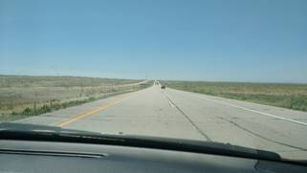
Virginia and I have been in the USA for almost 2 months now and it sure has seemed liked we are running a race, a race where the course is always changing. We are now on our second road trip to the West coast and have scheduled, re-scheduled and re-scheduled again to try and see as many of you as possible in the central and west coast USA. This has been a challenging venture, but one which we are more than happy to keep trying. We have enjoyed seeing those who are open for visits and look forward to other visits that have been scheduled. We understand the challenge this brings for everyone, no matter which side of the fence you are on.

Presently we are driving through Kansas headed for Colorado then we will head north west through Wyoming and Idaho, and on to Oregon and Washington. After visiting there, with a week out for a family vacation, we will head back to Illinois through Montana, North Dakota and Minnesota. Our tickets for return to Tanzania are scheduled for October 7th this year. Though others have been able to return this month to Tanzania, we do not know what the future months will hold for travel permissions. We ask that you all keep praying that we will be able to depart on schedule.

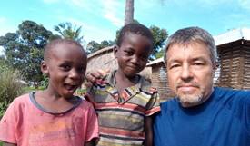
While we are running this race here in the USA, our friends and co-workers are still running the race on the other side of the globe in Tanzania. This week the Unity of Churches continued with further outreach into the village of Kimambi in the Kilwa District. What a thrill to see this work continuing in our absence. Continue to pray for our co-workers Jacob and Amy and Erin, and now Emmalee who is planning on returning this week to Tanzania, as they faithfully run the race in Kilwa for Jesus.

In November of last year, the village leaders of Ruhatwe came to the Church leaders and asked us if we would be willing to teach their children. These leaders are entirely Islamic. Their request was genuine, and they wanted to know if the Church was willing to start a Kindergarten school, called Chekachea in Swahili. For some time prior to this, we had been praying for opportunities for further outreach into the village of Ruhatwe. After the leadership discussed this open door, they decided that this would be a very effective step forward in expanding the Kingdom work. AIM mission was equally thrilled with this opportunity and donated significantly towards the starting of this project.

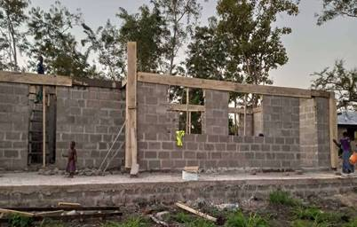
Just before our departure to the USA, work on the Kindergarten school in Ruhatwe started. We were able to get the building up to the Ring Beam level on the walls. The remaining work that is needed to be done is the roof, windows, doors, and then the inside furnishings. Raised funds have provided for the work that has been done so far, but we need further funding to continue to be able to complete the building. We would like to have this building functional for classes in January 2021, and we are praying that the needed funds would be raised in order for this to happen.

If you would like to contribute towards this Kindergarten school project, and the Lord is leading you in this, here is a link which the mission has setup for online donations. https://usgiving.aimint.org/project/ruhatwe-school-building
Please prayerfully consider what your role might be in this outreach toward the village children of Ruhatwe. Whether it be financially, encouragement or prayer, we are grateful for this opportunity to continue to spread the Good News of Jesus in the village of Ruhatwe.

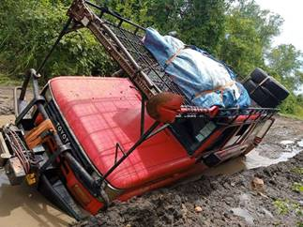
Another project that we ‘racing to complete’ is the ORRO project or “Operations restore Red October”. This Toyota Land Cruiser has been our work horse for many years and is need of a major ‘face lift’. Right now, the vehicle is completely torn apart and is being welded, painted, fixed and put back together again. We are trusting the Lord to provide the needed funds to complete this project before we return to Tanzania in October. The overall estimated cost, including tires for this project is $6500. Considering all the options for trustworthy transportation in Tanzania, this path seemed the best stewardship of the Lord’s funds. If you would like to donate to this project, the best way is to send a check to: Paul Tanner, 357 Phyllis Ave, Rochelle, IL 61068. Unfortunately, these funds are not tax deductible by the IRS, so we are not able to issue a tax-deductible receipt. Presently just over half of the funds have been raised. Another option is a GoFundMe account where you can donate. Here is the link for that https://www.gofundme.com/f/operation-restore-red-october

While we are “racing around the USA”, we are reminded that this race we run is all about making Jesus known. Buildings and vehicle and projects are included in this race, but we cannot lose focus in making Jesus Christ known to those who have never had the chance to know him. In the Kilwa District of Tanzania, there are still over 50 villages that have no witness for Jesus among them. Our hearts are passionate to keep Running this race until all have had the opportunity to hear of forgiveness of sins, and the Saving news of Jesus Christ. This is why we run this race.
Thank you for ‘Running” with us in this race and making this possible. May you also know the Joy of running this race and finishing the task that is laid out for you.

Until the King returns,
Paul for us all.

